AMASS TOOL – COMPREHENSIVE TECHNICAL DOCUMENTATION
An Enterprise-Grade Attack Surface Mapping Tool for Ethical Hacking & Penetration Testing
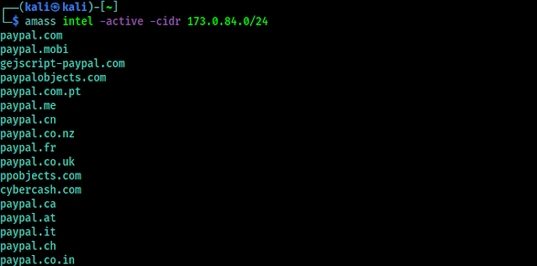
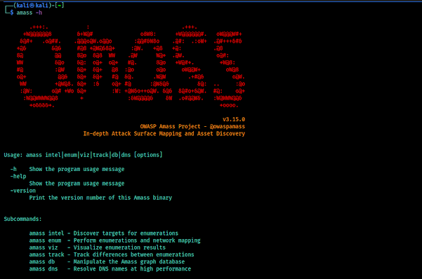
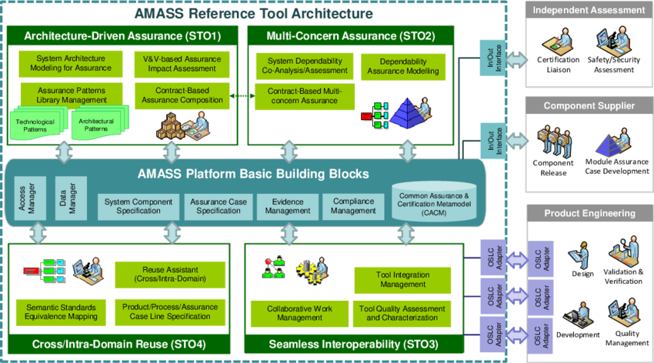

ABSTRACT
As organizations migrate toward cloud-native and distributed architectures, their digital attack surface expands rapidly. Identifying and managing this attack surface has become a critical challenge in cyber security. This document presents a comprehensive technical study of Amass, an advanced open-source attack surface mapping and subdomain enumeration tool developed for enterprise-scale reconnaissance. The report explains the theoretical foundation, internal architecture, operational modes, command usage, practical case study, advantages, limitations, and defensive considerations of Amass. The objective of this documentation is to provide an academic and practical understanding of Amass suitable for cybersecurity coursework, penetration testing training, and professional red team operations.

1. INTRODUCTION
Modern organizations rarely operate under a single domain or a small set of servers. Instead, they deploy hundreds or even thousands of assets across cloud platforms, content delivery networks, APIs, and third-party services. Many of these assets are unintentionally exposed to the internet, increasing the risk of security breaches.
Attack surface mapping is the process of discovering, cataloging, and analyzing all publicly accessible assets associated with an organization. Subdomain enumeration is a foundational component of this process.
Amass is a powerful reconnaissance framework designed to map an organization’s external attack surface using a combination of OSINT, DNS analysis, certificate transparency, web scraping, and active enumeration techniques. This document explores Amass in detail and explains why it is considered an industry-standard reconnaissance tool.

2. OBJECTIVE OF THE STUDY
The objectives of this documentation are:
- To understand attack surface mapping in cyber security
- To study the architecture and working mechanism of Amass
- To analyze Amass operational modes and commands
- To demonstrate real-world usage through a practical case study
- To evaluate strengths, limitations, and security implications
- To provide exam-ready and submission-ready technical content

3. BACKGROUND: ATTACK SURFACE MAPPING IN CYBER SECURITY
Attack surface mapping focuses on identifying all possible entry points that an attacker could exploit. These entry points often include:
- Subdomains and DNS records
- Cloud-hosted services
- APIs and microservices
- Forgotten or deprecated assets
- Third-party integrations
Traditional tools focus on limited enumeration techniques. In contrast, Amass integrates multiple intelligence sources and correlates them to build a comprehensive view of an organization’s exposure.
Amass operates across both passive and active reconnaissance, making it suitable for large-scale professional engagements.

4. OVERVIEW OF AMASS TOOL
Amass is an open-source reconnaissance framework written in Go and developed to support enterprise-grade security assessments. It is widely used by penetration testers, red teams, blue teams, and bug bounty hunters.
Unlike lightweight enumeration tools, Amass emphasizes accuracy, correlation, and scalability. It supports hundreds of data sources and provides structured outputs suitable for automation and reporting.
Amass is not an exploitation tool. Its purpose is to discover, organize, and contextualize attack surface data.

5. ARCHITECTURE AND WORKING MECHANISM

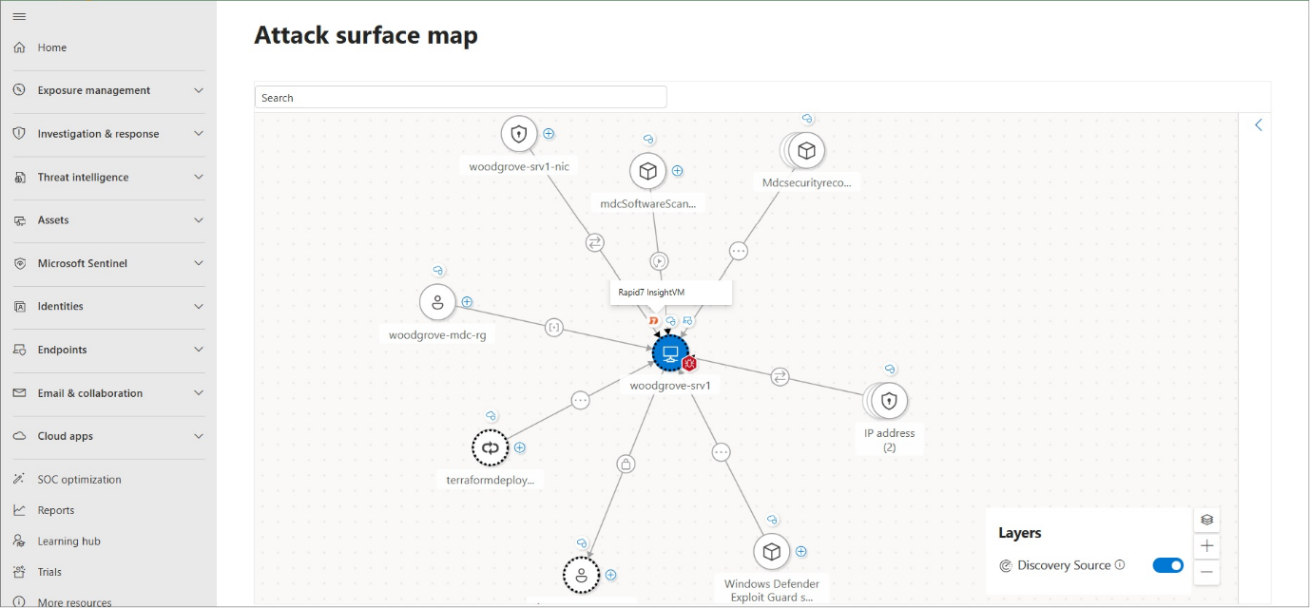
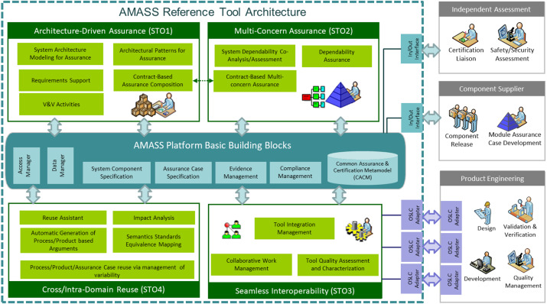
Amass follows a modular and layered architecture:
- Data Source Integration
Amass collects information from OSINT sources such as search engines, APIs, certificate transparency logs, and DNS records.
- DNS Enumeration Engine
The tool performs DNS queries to validate and expand discovered assets.
- Graph-Based Correlation
Relationships between domains, IPs, ASNs, and organizations are mapped internally.
- Active Enumeration (Optional)
Brute-force and probing techniques are used to discover additional assets.
- Result Storage and Output
Results are stored in structured formats such as JSON for further analysis.
This architecture enables Amass to scale effectively for large organizations.

6. INSTALLATION AND ENVIRONMENT
Amass is pre-installed in Kali Linux and is also available as a standalone binary.
To verify installation:
amass version
Amass requires internet connectivity for OSINT data sources and performs best in professional testing environments.

7. OPERATIONAL MODES OF AMASS
Amass provides multiple operational modes to suit different engagement requirements:
- Intel Mode – Collects intelligence without DNS resolution
- Enum Mode – Performs full subdomain enumeration
- Viz Mode – Visualizes relationships between discovered assets
- Track Mode – Monitors changes in attack surface over time
These modes allow Amass to be used by both red teams and blue teams.

8. COMMAND USAGE AND ANALYSIS
8.1 Passive Enumeration
amass enum -passive -d example.com
Uses OSINT sources without directly querying the target infrastructure.

8.2 Active Enumeration
amass enum -active -d example.com
Performs DNS probing and brute-force techniques.

8.3 Specifying Data Sources
amass enum -d example.com -src
Displays which data sources contributed to each finding.

8.4 Saving Output
amass enum -d example.com -o amass_results.txt
Stores results for reporting and further analysis.

8.5 Visualization Mode
amass viz -d example.com
Generates a visual representation of asset relationships.

9. PRACTICAL CASE STUDY
Scenario
A security assessment is conducted on a fictional organization named example-corp.com.
Execution
amass enum -d example-corp.com
Observations
- Discovered numerous API and cloud subdomains
- Identified third-party service dependencies
- Mapped IP ranges and autonomous systems
Impact Analysis
Amass provided a comprehensive view of the organization’s attack surface, enabling precise prioritization of further security testing.

10. ADVANTAGES OF AMASS
- Enterprise-grade reconnaissance capability
- Integrates hundreds of OSINT and DNS sources
- Supports passive and active enumeration
- Highly scalable and automation-friendly
- Suitable for red team, blue team, and bug bounty use

11. LIMITATIONS OF AMASS
- Steeper learning curve for beginners
- Requires configuration for optimal results
- Slower execution due to depth of analysis
- Higher resource consumption compared to lightweight tools

12. AMASS VS OTHER ENUMERATION TOOLS
Tool | Approach | Best Use Case
Amass | Attack surface mapping | Enterprise assessments
Sublist3r | OSINT-based | Stealth recon
DNSMAP | Brute force | Quick discovery
DNSENUM | Mixed methods | Academic & medium-scale testing
Amass is the preferred choice for large-scale and professional engagements.

13. SECURITY AND DEFENSIVE CONSIDERATIONS
Organizations can reduce exposure identified by Amass by:
- Maintaining accurate asset inventories
- Monitoring certificate transparency logs
- Regularly auditing DNS records
- Decommissioning unused subdomains
- Implementing strong access controls

14. LEGAL AND ETHICAL CONSIDERATIONS
Amass must be used only with proper authorization. Due to its depth and scale, misuse of Amass can lead to serious legal consequences.

15. CONCLUSION
Amass represents the evolution of reconnaissance from simple enumeration to full-scale attack surface mapping. Its ability to correlate data from multiple sources makes it an indispensable tool for modern penetration testing and defensive security operations. Mastery of Amass equips cybersecurity professionals with a deep understanding of how attackers and defenders perceive organizational exposure.

16. REFERENCES
- Kali Linux Official Documentation
- OWASP Attack Surface Analysis
- OSINT Framework
- DNS RFC Standards

